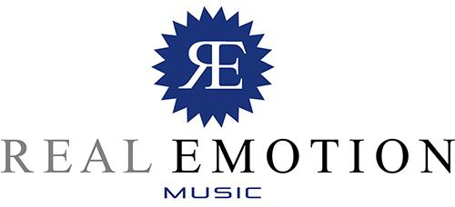

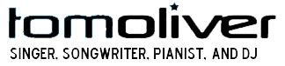

SHOW LIST (Excerpts)

Space, Ibiza

Sporting Club, Monaco

Nikki Beach, St Tropez

Café del Mar, Ibiza

Fairmont, Dubai

Ku De Ta, Bali (Asia´s Most Famous Clubs)

Ibiza Festival, Nice, France

Olympia, Mumbai

C/o Pop Festival, Germany

and many others around the world...

